Project Report on
SNAPPY – A WEB CHAT APPLICATION
Submitted in the partial fulfilment of the requirement for the award of degree of
Bachelor of Technology
in
Computer Science and Engineering
Batch
(2022-2026)


Submitted to: Submitted by:
Dr. Naveen Bilandi Aniket
(Associate Professor, CSE)​ 12200970
​ ​

DEPARTMENT OF COMPUTER SCIENCE AND ENGINEERING
DAV UNIVERSITY
JALANDHAR- PUNJAB 144012
ACKNOWEDGEMENET

I would like to express my sincere gratitude to my project guide, Dr. Naveen Bilandi (Associate Professor, CSE) for their valuable guidance, constructive feedback, and continuous support throughout the duration of this project. I am also thankful to Dr. Rahul Hans (coordinator, CSE)
and the Department of Computer Science and Engineering for providing the necessary resources and an encouraging academic environment.

My appreciation extends to all faculty members and classmates whose suggestions and cooperation helped strengthen the quality of this work. Lastly, I am deeply grateful to my family for their constant encouragement and support, which motivated me to complete this project successfully.

DECLARATION

I, Aniket , hereby declare that the work which is being presented in this project titled “Snappy – A Web Chat Application” by me, in partial fulfillment of the requirements for the award of Bachelor of Technology (B.Tech) Degree in “Computer Science and Engineering” is an authentic record of my own work carried out under the guidance of Dr. Naveen Bilandi(Associate Professor, CSE).
To the best of my knowledge, the matter embodied in this report has not been submitted to any other University/ Institute for the award of any degree or diploma.

Aniket
12200970
Btech CSE

CONTENTS

Sr.no | Title | Page.no
1. | Abstract | 5
2. | Introduction | 6
3. | Literature Review | 7-10
4. | Objectives | 11-12
5. | Methodology | 13-17
6. | Limitations | 18-23
7. | DFD | 24-25
8. | Screenshots | 26-28
9. | Future Scope | 29-34
10. | Conclusion | 35
11. | Reference | 36-37

ABSTRACT
The Chat Application System is a real-time communication platform built using the MERN stack (MongoDB, Express.js, React.js, Node.js) along with Socket.io for instant bidirectional messaging. The objective of this project is to provide users with a seamless and efficient chat experience, enabling them to register, authenticate, set profile avatars, and exchange messages instantly.
The system resolves common communication challenges by offering modern features like secure login, real-time updates, dynamic contact lists, persistent chat history, and user-friendly UI. With the rising demand for fast communication tools, this project demonstrates how modern web technologies can be integrated to build a scalable, interactive, and responsive chat solution.
This Chat Application highlights the practical use of REST APIs, Web Sockets, authentication workflows, and database-driven messaging. It serves as a modern illustration of how full-stack development can be applied in real-world communication systems.

INTRODUCTION
Digital communication has evolved rapidly, leading to the need for reliable, fast, and interactive chat systems. Traditional messaging methods using SMS or email are slow and not suited for real-time exchange. With web-based technologies and socket communication, instant messaging has become the backbone of modern communication platforms.
This Chat Application System provides a simple yet powerful platform for users to:
- Create accounts
- Log in securely
- Set profile avatars
- View online/offline statuses
- Send & receive real-time messages
- Access saved chat history anytime
The system uses Socket.io to enable real-time communication between clients and the server, ensuring messages are delivered instantly without page reloads.
This project demonstrates how modern technologies work together to create a responsive full-stack communication platform.

LITERATURE REVIEW
Research and existing chat platforms show several technological approaches to messaging systems:
1. Traditional Communication Challenges
- Earlier systems relied on SMS, emails, or slow polling methods. These suffer from:
- No real-time updates
- High delays
- Limited user interaction
- Manual refresh requirements
2. Need for Real-Time Messaging
- Studies highlight the importance of:
- Instant message delivery
- Dynamic UI updates
- Minimal bandwidth usage
- Low latency communication
- WebSockets and socket-based architectures address these issues efficiently.
3. Web-Based Messaging Systems
- Modern systems (WhatsApp Web, Messenger, Slack) use WebSockets for:
- Live chat
- Presence indicators
- Typing notifications
- Group messaging
4. MERN Stack for Chat Apps
The MERN stack is widely used due to:
- Fast development
- Component-based frontend (React)
- Scalable backend (Node + Express)
- Flexible NoSQL storage (MongoDB)
5. Security Considerations
- Key security concerns identified in research:
- User authentication
- Message encryption
- Protected APIs
- Preventing XSS and CSRF attacks
6. Gaps in Existing Systems
- Some widely observed drawbacks:
- Heavy resource usage
- Complex UI
- High maintenance cost
- Limited customizability
7. Contribution of This Project
- The proposed chat app aims to:
- Offer a simple but powerful UI
- Provide real-time messaging
- Include avatar support
- Maintain chat history securely

OBJECTIVES
The primary objective of the Real-Time Chat Application is to deliver a fast, secure, and user-friendly communication platform using the MERN stack. The system aims to offer seamless real-time messaging, efficient user management, and a modern interface to enhance overall interaction. The detailed objectives are as follows:

1. To Enable Real-Time Communication
The system aims to provide instant message delivery using Socket.io. This ensures that users can chat without delays, receive messages instantly, and experience smooth two-way communication.
2. To Implement a Secure User Authentication System
One of the key objectives is to support safe login and registration processes by using encrypted passwords and authentication mechanisms. This ensures that only authorized users can access the chat platform.
3. To Allow User Profile and Avatar Management
The system enables users to set profile avatars and maintain personal information. This enhances personalization and helps users manage their identities within the chat environment.
4. To Provide a Smooth and Responsive User Interface
A clean and intuitive React-based frontend ensures a seamless experience across devices. This objective focuses on delivering a modern, responsive, and user-friendly interface.
5. To Persist and Retrieve Message History
The application stores chat records in MongoDB so that users can access past conversations whenever needed. This objective ensures continuity in communication and long-term data availability.
6. To Track Online Users Efficiently
Using Web Sockets, the system maintains a list of active users. This allows participants to know who is online and improves overall interaction within the chat system.
7. To Ensure Secure Communication
The system aims to protect user data and API interactions through secure development practices. This includes safe data handling, protected routes, and encrypted communication where necessary.
8. To Enhance Messaging Efficiency
By using real-time technologies, the system ensures fast and reliable message delivery without page reloads. This objective focuses on improving communication speed and overall performance.
9. To Improve User Experience
The chat platform aims to deliver a smooth, interactive, and engaging environment for users. A modern design and intuitive navigation contribute to a better overall experience.
10. To Ensure Scalability for Future Expansion
Built on a modular MERN architecture, the system is designed to scale easily as the number of users or features grows. This ensures long-term viability and flexibility for future enhancements.

METHODOLOGY
The methodology outlines the structured approach used to design, develop, test, and deploy the Real-Time Chat Application. Following the Software Development Life Cycle (SDLC), each phase ensures accuracy, efficiency, and reliability of the system. The major phases are described below:

1. Requirement Analysis
This is the initial phase where all functional and technical requirements of the chat system are gathered and analyzed.
Activities:
• Identifying the need for real-time messaging between multiple users.
• Understanding requirements related to user authentication and secure access.
• Collecting requirements for persistent message storage and history retrieval.
• Gathering needs related to profile avatar management and online status visibility.
• Determining the expected performance for live messaging through web sockets.
Output:
A clear requirement specification document describing system behaviour, features, and constraints.

2. System Design
This phase focuses on converting requirements into a structured architectural blueprint of the system.
Components:
• ER Diagrams: Representing users, messages, and their relationships.
• REST API Structure: Planning routes for authentication, profile updates, and message handling.
• Socket.io Architecture: Designing event flows for message sending, receiving & user status updates.
• React Component Structure: Building UI components such as login page, chat window, contacts list, and profile section.
Output:
A well-defined system architecture ready for development.
3. Database Design & Schema Structuring
A well-organized MongoDB database is designed to store users, messages, and profile-related information.
Activities:
• Defining all the collections such as Users and Messages done.
• Adding attributes like timestamps, avatar strings, sender/receiver IDs.
• Ensuring optimized indexing for fast retrieval of chat history.
• Structuring schemas to support scalability and performance.
Output:
An optimized NoSQL database structure ready for integration.

4. System Development (Frontend + Backend)
Actual coding and system creation take place in this phase.
Frontend Development:
- Creating web pages using React, Tailwind CSS, and JavaScript.
- Designing user-friendly interfaces for login, signup, chat window, contacts list, and profile management.
- Ensuring responsiveness, easy navigation, and accessibility.
Backend Development:
- Implementing server-side logic using Node.js and Express.
- Developing APIs for login, registration, message sending/receiving, and user profile updates.
- Connecting the system with the database (MongoDB).
- Implementing authentication, session management, and user roles.
Output:
A fully functional, interactive chatbot system with smooth frontend-backend communication.
5. Integration
This phase connects all the individual components to work as a unified system.
Activities:
• Linking Socket.io with frontend and backend for live messaging.
• Ensuring the database updates in sync with message events.
• Validating data flow between UI, API, and MongoDB.
Output:
A fully integrated real-time chat application functioning smoothly.

6. Testing
Testing ensures the application works reliably under different scenarios and meets all functional requirements.
Types:
• UnitTesting: Testing individual components and functions of the application.
• Integration Testing: Ensuring proper communication between modules (API + Socket + UI).
• UI Testing: Checking the layout, responsiveness, and user interactions.
• Socket Testing: Verifying live message delivery and connection stability of the application.
• Error Handling Validation: Ensuring graceful handling of invalid inputs or server issues.
Output:
A stable, error-free system ready for deployment.

7. Deployment
After thorough testing, the system is deployed for public or team usage.
Activities:
• Hosting the backend server using platforms like Render, Railway, or AWS EC2.
• Deploying the React frontend on services like Vercel or Netlify etc.
• Verifying live chat functionality on the production server.
Output:
A fully operational real-time chat application available online.

8. Maintenance & Updates
This final phase ensures continued system performance, security, and feature enhancement.
Activities:
• Fixing the bugs and other issues that are reported by the users.
• Improving performance and optimizing Socket.io events so user can use it.
• Updating UI elements, adding new features, and ensuring compatibility.
• Performing regular security checks and server updates.
Output:
A continuously improved and well-maintained chat system capable of scaling with future requirements.

LIMITATIONS
Although the chat application performs well for real-time text communication, it still has several limitations that affect performance, security, and future scalability. These limitations show the areas that need enhancement in upcoming versions.

1. Strong Dependence on Internet Connectivity
The chat system works only when the user has a stable internet connection.
Detailed Concerns:
- Poor or unstable networks may result in delayed or failed message delivery.
- Users can get disconnected from the chat if the connection drops.
- Real-time updates may lag on slower connections.
Impact:
Interruptions in chat flow can reduce the reliability and smoothness of conversations.

2. No Support for Media or File Sharing
Currently, the application allows only text-based communication.
Detailed Concerns:
- Users cannot send images, documents, audio, or videos.
- Collaboration requiring file exchange is not possible.
- Users may switch to other platforms for sharing files.
Impact:
Limited communication flexibility and reduced usability for professional or academic tasks.

3. Absence of Audio/Video Communication Features
The system does not include any voice or video calling functionality.
Detailed Concerns:
- No quick voice chat option for faster communication.
- No face-to-face interaction or video meetings.
- Teams and groups still need third-party apps for audiovisual communication.
Impact:
Users experience restricted communication modes, especially for meetings or discussions.

4. Basic Profile and Avatar Management
User avatars are stored as simple image paths without advanced processing.
Detailed Concerns:
- Large images may take longer to load.
- No automatic compression or resizing of profile pictures.
- Limited support for high-quality avatars.
Impact:
Profile pictures may load slowly or appear inconsistent across devices.

5. Limited Scalability for Large User Traffic
The current system is designed for small to medium-sized user groups.
Detailed Concerns:
- High user load may slow down message processing.
- Socket connections may become less stable during heavy usage.
- Database performance may degrade with large datasets.
Impact:
Reduced performance and slower message delivery as the number of users grows.

6. Limited Advanced Chat Features
Although real-time chat works smoothly, some modern features are missing.
Detailed Concerns:
- No typing indicators (e.g., “Typing…”).
- No read receipts for seen/unseen messages.
- No online/offline activity tracking.
- No message reactions, replies, or threading.
Impact:
The chat experience remains basic compared to modern messaging apps.

7. Security Limitations
The application does not yet support advanced, industry-grade security measures.
Detailed Concerns:
- No end-to-end encryption for messages.
- Chats rely mainly on backend security protections.
- Sensitive information may need stronger encryption layers.
Impact:
Lower security assurance for confidential or professional communication.

8. No Native Mobile Application
The system is currently available only through a web browser.
Detailed Concerns:
- No dedicated Android or iOS app.
- No push notifications for new messages.
- Limited mobile convenience for daily usage.
Impact:
Lower user engagement and accessibility, especially for mobile users.

Data Flow Diagram
A Data Flow Diagram (DFD) is a graphical tool used in system analysis to illustrate how data moves through a system. It provides a simple and clear way to understand how information flows—where data comes from, how it is processed, and where it is stored. A DFD helps break the system into smaller parts so developers, designers, and stakeholders can easily understand how the system operates.
A DFD does not focus on technical details like programming or database code. Instead, it highlights the logical flow of data within the system.

DFD Level-0

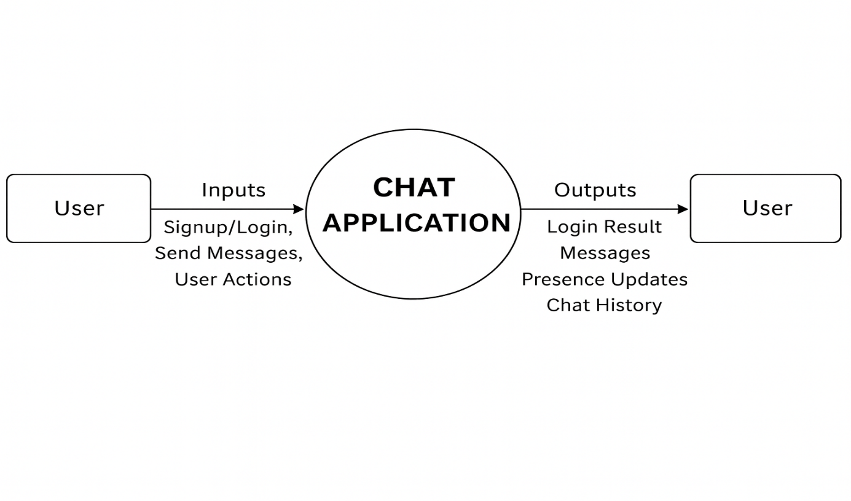

A DFD Level-0, also known as the Context Diagram, provides a high-level overview of how the Chat Application System operates. It represents the entire application as a single process and shows how it interacts with external users. At this level, the internal modules such as authentication, message storage, or chat processing are not shown. Only the main inputs and outputs of the system are displayed.
In the Chat Application System, the Level-0 DFD explains how users interact by creating accounts, logging in, sending messages, and receiving real-time chat updates. The system processes these actions and returns outputs such as login responses, delivered messages, chat history, and online/offline status of other users.
The purpose of the Level-0 DFD is to give a simple and clear understanding of how data enters the chat system, how it is processed, and how it flows back to users—without focusing on technical or internal processing details.

DFD Level-1
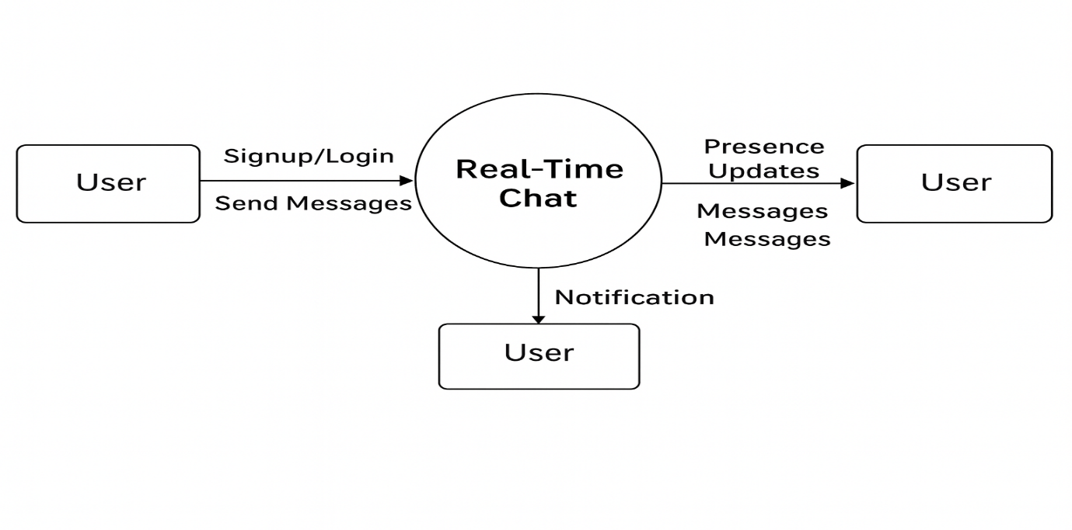

External Entities:
- User – interacts with the chatbot system (sends messages, receives replies, manages profile).
- Admin (Optional) – manages users, monitors activity (if you have admin features).

Processes (Main Functions):
- User Authentication
  - Handles signup, login, and session management.
  - Input: User credentials
  - Output: Authentication status (success/failure)
- User Management / Profile
  - Manages user info, avatars, and profile updates.
  - Input: User profile data
  - Output: Updated user info
- Message Processing
  - Handles sending, receiving, storing messages in MongoDB.
  - Input: Message text from user
  - Output: Response to user, saved message
- Contacts / Chat List
  - Retrieves user’s contacts and chat history.
  - Input: User ID
  - Output: List of contacts and previous messages
- Chatbot Response / AI (Optional)
  - Generates automated replies (if any AI logic is implemented).
  - Input: User message
  - Output: Chatbot reply

Data Stores:
- User Database (MongoDB) – stores user credentials, profiles.
- Message Database (MongoDB) – stores chat messages between users.

Data Flows (Examples):
- User → User Authentication → User DB (credentials verification)
- User → Message Processing → Message DB (store message)
- Message DB → Message Processing → User (retrieve & display messages)
- User → User Management → User DB → User (update profile info)
- User → Contacts/Chat List → Message DB → Contacts/Chat List → User (retrieve chat history)

SCREENSHOTS

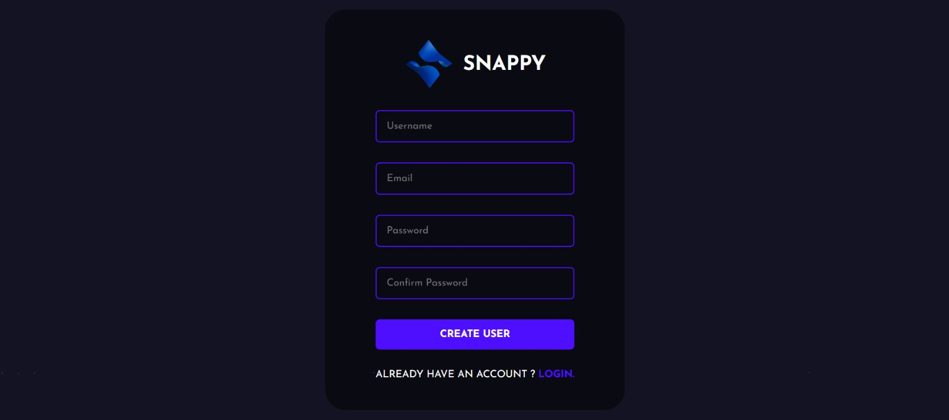

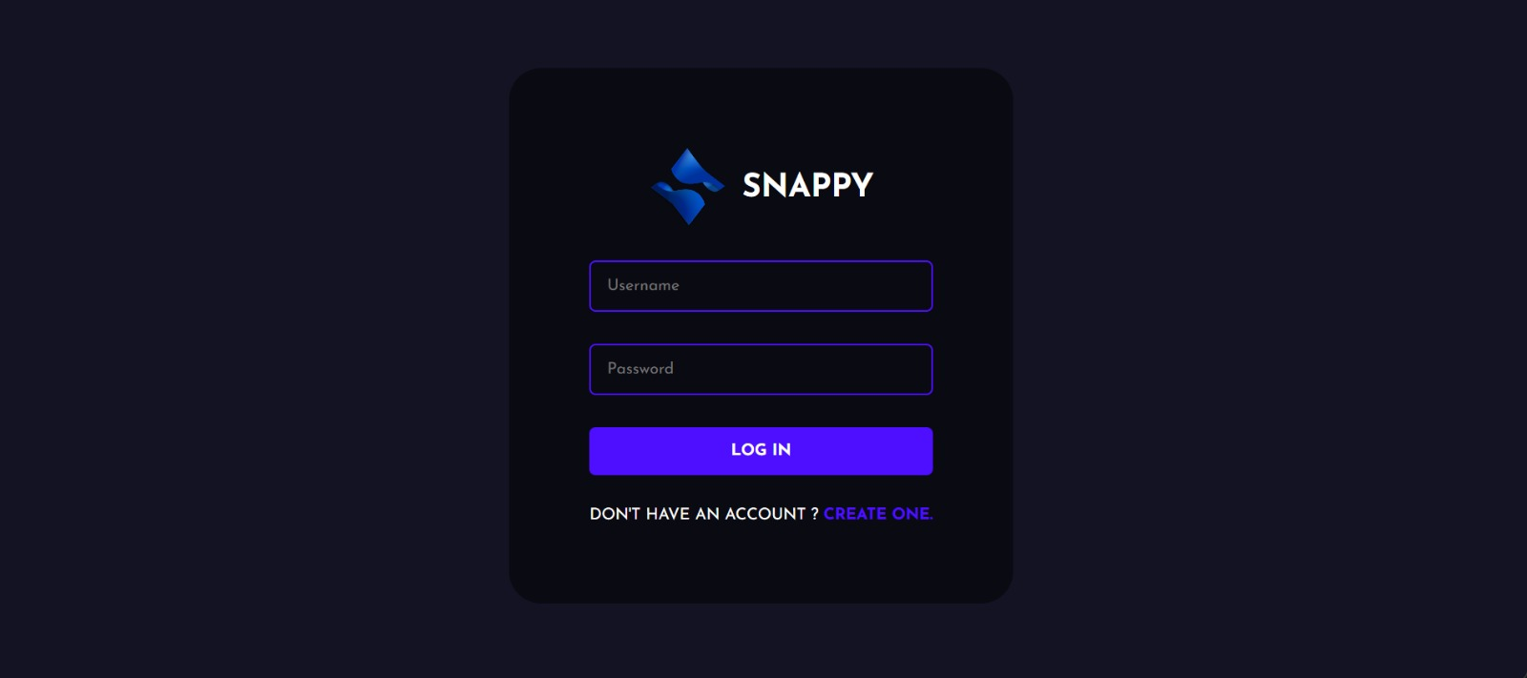
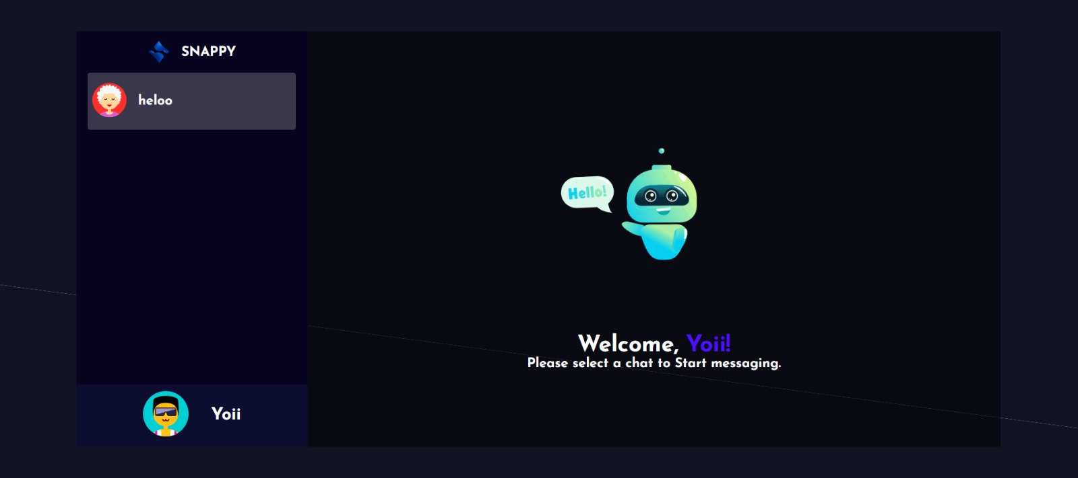

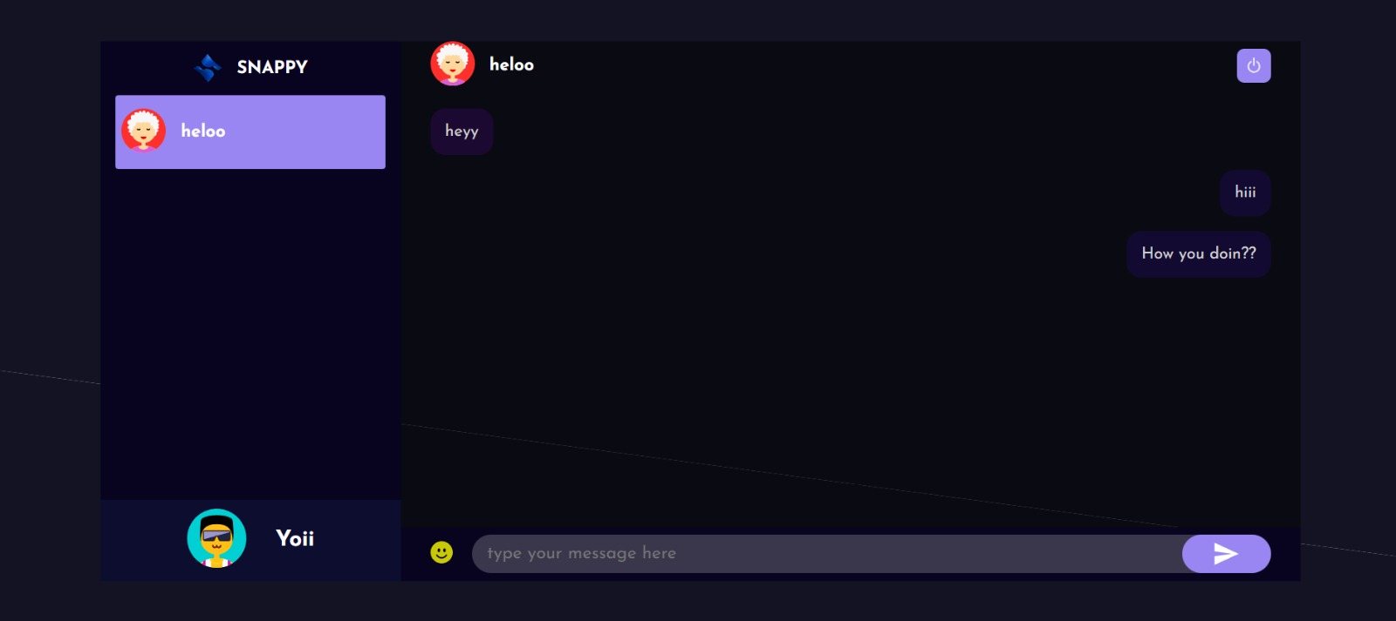

FUTURE SCOPE
The Chat Application has a wide range of possibilities for expansion beyond its current features. As communication technologies evolve and user expectations rise, the system can be enhanced with next-generation capabilities to transform it into a smarter, faster, and more interactive communication platform. The following detailed points describe how the project can grow in the future:

1. Artificial Intelligence (AI) & Machine Learning (ML) Integration
AI and ML can significantly enhance the efficiency and intelligence of the chat application.
Future enhancements include:

• Smart Message Suggestions
AI can analyze user typing patterns and provide auto-suggestions or quick replies to improve conversation speed.

• Message Categorization & Spam Detection
AI models can automatically filter spam messages, detect abusive content, and organize conversations.

• AI-powered Chat Moderation
Content moderation using NLP to detect inappropriate or harmful content within chats.

• Smart Search Functionality
ML algorithms can make message search faster and more accurate by understanding context.

2. Data Analytics & Predictive Insights
Advanced analytics can turn raw communication data into meaningful insights.

• Predictive User Activity
The system can predict when users are most active and optimize notifications or features accordingly.

• Chat Traffic Analysis
Charts and dashboards for admins showing peak activity times, number of messages exchanged, and user engagement.

• User Behavior Insights
Understanding which features users prefer, helping developers upgrade the app effectively.

3. Mobile Application Development
A dedicated Android/iOS app can greatly enhance accessibility and engagement.

• Push notifications for new messages

• Voice note support

• Image/Video sharing

• Real-time chat updates
Mobile apps allow users to stay connected anytime, increasing engagement and usability.

4. Integration with External Communication Tools
The system can be integrated with third-party platforms to extend functionality.

• Google Meet/Zoom for video calls

• WhatsApp API for external message notifications

• Email integration for chat summaries or alerts
This provides a unified communication experience.

5. End-to-End Encryption (E2EE)
To enhance privacy and security:

• Messages can be encrypted end-to-end

• Secure key exchange mechanisms

• Encrypted media sharing
This makes the chat system highly secure and trustworthy.

6. Blockchain for Message Integrity & Security
Blockchain can be used to securely store:

• Chat logs

• User verification records

• Message timestamps
This ensures message authenticity and prevents tampering.

7. Group Management & Community Expansion
The system can evolve to support large groups or communities.

• Admin level permissions

• Moderators and group managers

• Community announcements and polls

• Private and public groups
This transforms the app into a community-based communication platform.

8. Automated Chatbots & Virtual Assistants
A chatbot can assist users with:

• FAQs

• App navigation

• Smart reply suggestions

• Scheduling messages

• Automated reminders
This improves user support and reduces manual intervention.

9. Cloud Storage & Real-time Sync
Cloud technology can improve scalability and performance.

• Faster message delivery

• Instant sync across devices

• Unlimited message storage

• Backup and restore support
Cloud migration ensures the system handles large user loads efficiently.

10. Voice & Video Calling Features
Future versions may include:

• One-on-one video calling

• Group video conferencing

• Voice calls with HD quality

• Screen sharing support
This makes the app a complete communication platform.

11. Rich Media Sharing and Collaboration Tools
Enhancements may include:

• File sharing (PDF, documents)

• Voice messages

• Stickers, GIFs, emojis

• Real-time collaborative whiteboard
These make conversations interactive and fun.

12. User Status Monitoring & Activity Tracking
Future improvements could include:

• Online/offline status

• Last seen timestamps

• Typing indicators

• Read receipts and delivered receipts
This improves transparency between users.

13. Multi-Language Support
The system can support users from different regions.

• Automatic translation of messages

• UI language switching

• Regional sticker packs
This increases global usability.

14. AI-based Voice Assistant Integration
Future versions can support:

• Voice-activated message sending

• AI reading out messages

• Voice commands for navigation
This makes the app accessible for differently-abled users.

15. Enhanced Security & Authentication
Security features may include:

• Two-factor authentication (2FA)

• Biometric login (Face/ Fingerprint)

• Device-level authorization
This ensures only authorized users access chats.
CONCLUSION

The development of the Chat Application marks an important step toward improving and modernizing real-time communication between users. Traditional communication methods—such as SMS, emails, or offline messaging—often lack speed, convenience, and interactivity. They also fail to support features like instant delivery, group communication, media sharing, and real-time presence updates. This project successfully overcomes these limitations by providing a fast, user-friendly, and efficient platform designed to facilitate seamless communication.
Through this chat system, users can exchange messages instantly, share information, and stay connected in a more interactive environment. The application offers a centralized platform where conversations, user profiles, and message histories are stored securely and can be accessed whenever needed. This eliminates dependence on third-party messaging tools, reduces communication delays, and enhances the overall user experience
For administrators, the platform provides the ability to monitor user activity, ensure data security, and manage system operations effectively. Features such as user authentication, secure database connectivity, and controlled access help maintain a safe and private communication environment.
The project demonstrates how modern web technologies—such as Node.js, Express, databases, frontend frameworks, and real-time communication tools like WebSockets—can be combined to build a scalable and robust chat application. The design principles focus on usability, speed, and security, making the system adaptable for future expansion such as media sharing, group chat, voice/video calling, AI-based features, and cloud integration.
Overall, the Chat Application not only simplifies and accelerates communication but also highlights the importance of digital connectivity in today’s fast-paced world. By offering a reliable, flexible, and interactive messaging platform, this project sets the foundation for building advanced communication systems that meet modern user expectations and support continuous technological evolution.
REFERENCE

1. Online Articles and Blogs
- Articles on real-time chat applications, WebSocket communication, and messaging system design from Medium, GeeksforGeeks, and Dev.to.
- Blogs on MERN stack development, user authentication, and building chat interfaces from TutorialsPoint and W3Schools.
- Articles discussing chat app security, real-time communication trends, and messaging APIs from FreeCodeCamp, HRZone Tech Blogs, and LinkedIn Articles.

2. Official Documentation
- React.js: https://reactjs.org
- Node.js: https://nodejs.org
- Express.js: https://expressjs.com
- MongoDB: https://www.mongodb.com
- JavaScript (MDN Web Docs): https://developer.mozilla.org
- Socket.io (Real-time Communication): https://socket.io

3. Technical Tools & Libraries Used
- Documentation and community repositories for MERN Stack (MongoDB, Express, React, Node.js) from GitHub.
- Visual Studio Code documentation: https://code.visualstudio.com
- Postman API testing documentation: https://www.postman.com
- Git version control documentation: https://git-scm.com
- Socket.io GitHub Repository for understanding real-time events and communication flow.

4. Developer Communities
- Stack Overflow: https://stackoverflow.com — used for resolving doubts related to backend APIs, WebSockets, and debugging.
- GitHub: https://github.com — for exploring open-source chat applications and real-time communication examples.
- Reddit Communities like r/webdev, r/node, and r/reactjs for development tips, best practices, and real-time messaging discussions.

